Chapter 5 homework

- Complete exercises 5.4, 5.12, and 5.23
- Find the following for the copier maintenance data set (see #1.20) using matrix methods (do not use lm()): b, , e, SSTO, SSE, , 95% C.I. for E(Y_{h}) at X_{h}=6, and 95% P.I. for Y_{h(new)} at X_{h}=6
- Examine tests from 2012
- Reproduce all examples in the notes

Partial answers

5.4
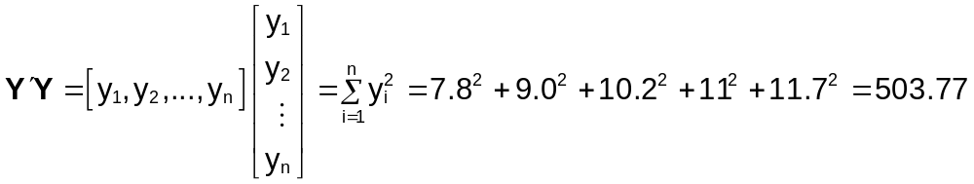
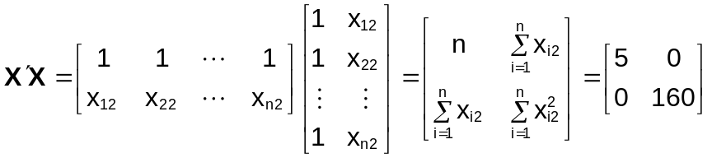
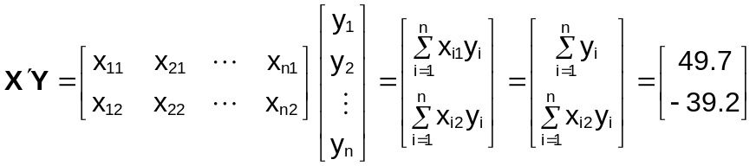

Here is my code and the corresponding output. There are other ways to do this problem!

> X<-c(8,4,0,-4,-8)
> Y<-c(7.8, 9, 10.2, 11, 11.7)

> sum(Y)
[1] 49.7
> sum(Y^2)
[1] 503.77
> X%*%Y #also sum(X*Y) using elementwise multiplication and summing the result
[,1]
[1,] -39.2
> sum(X)
[1] 0
> length(X)
[1] 5
> sum(X^2)
[1] 160

5.12
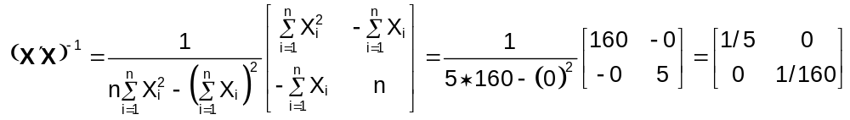

5.23
a) 1) 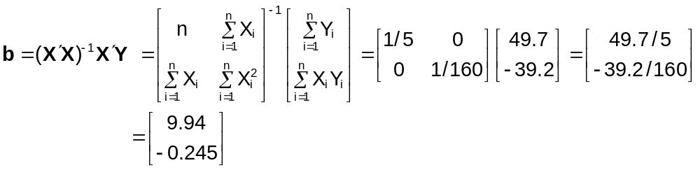

From the answer key
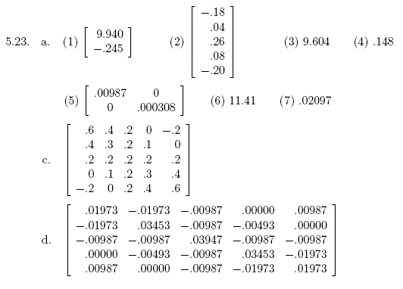

Extra problem with the copier maintenance data: You can check most of your answers with your past work for Chapters 1-4 or additional calculations as shown in class for Chapter 5.

